**Basic User:**

**Feature 1: User Login**

User should be redirected to the login page when she opens the app for the first time. Basic user should be given option to register as a new user. User will be auto logged in after the first login.

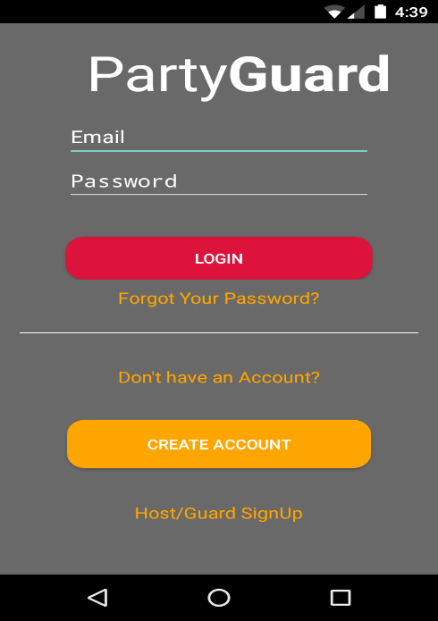

## Feature 2: Registering User

Basic User should be redirected to the registration page when he/she clicks on “Register” button in the login page.

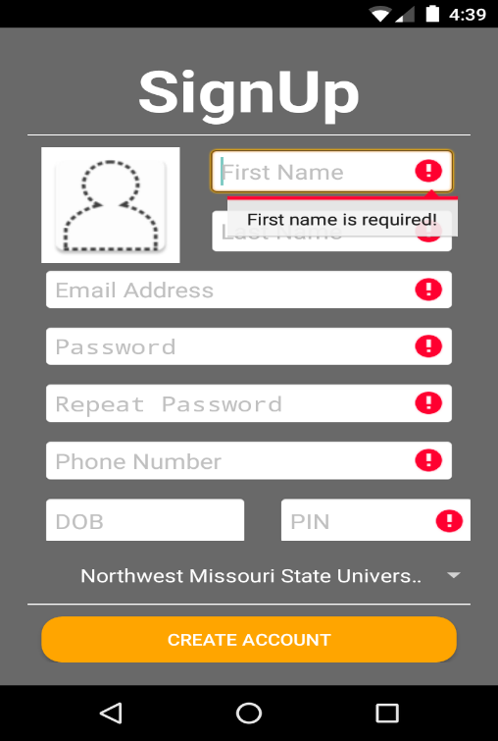

## Feature 3: Reset Password

User can reset his/her password by providing the user id.

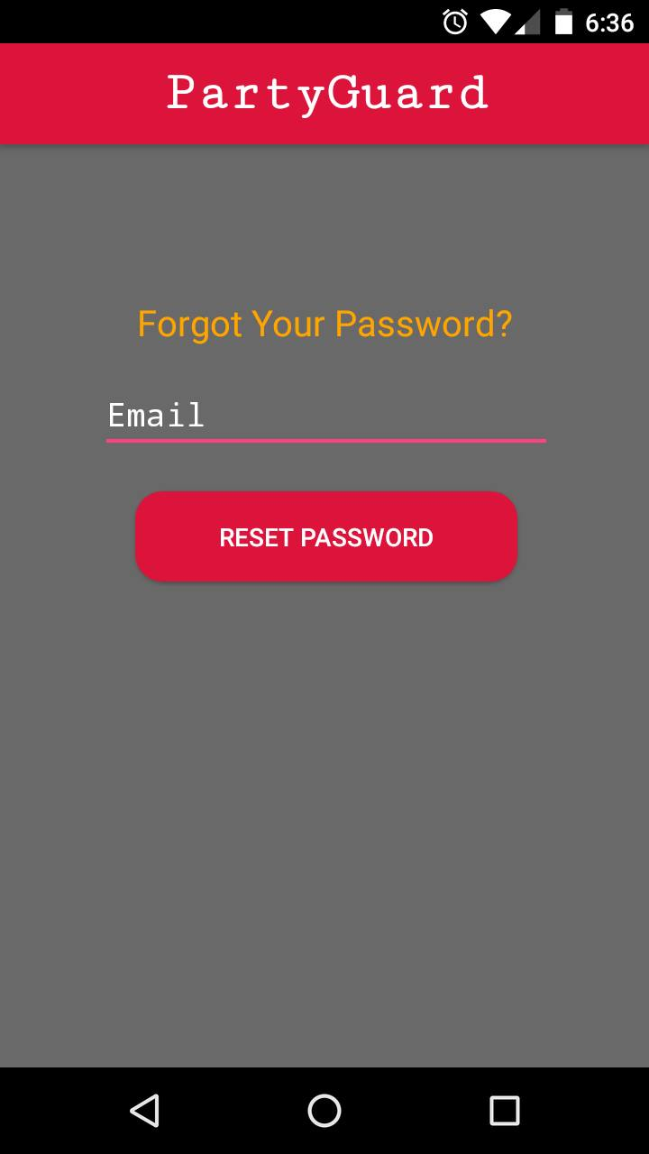

## Feature 4: How to use this app?

User should be redirected to “How to use this app?” screen, when user logins or registers for the first time.

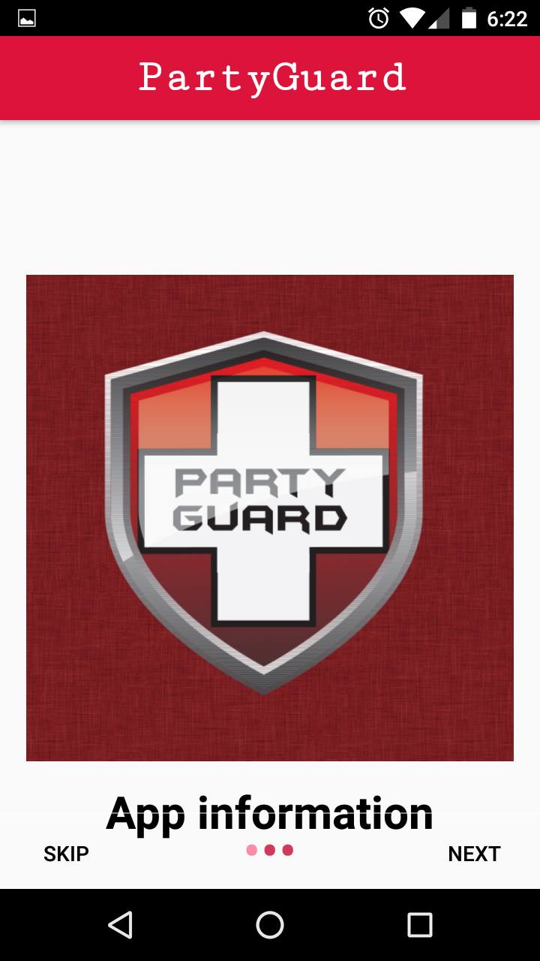

## Feature 5: Universities Screen

All the list of universities that are registered in the website will be displayed in this screen. The user will choose the university from this list.

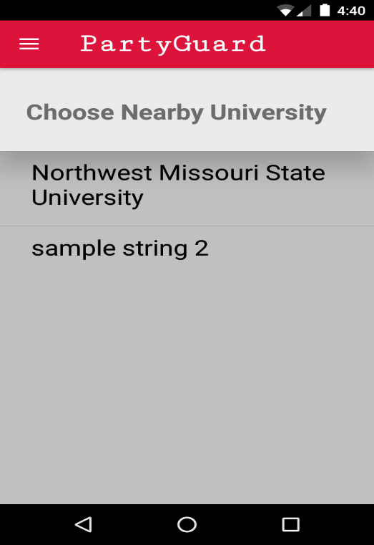

## Feature 6: Fraternities Screen

The List of fraternities that are available in the user’s location are enabled for user to select. Along next to the names should be a small image of the fraternity house provided by the Host user via the website.

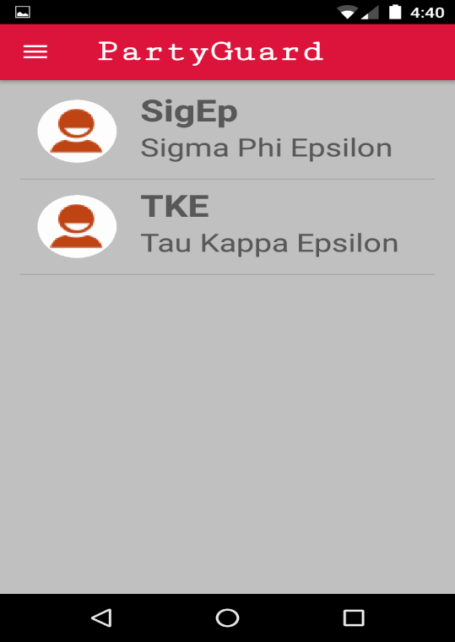

**Feature 7: Report Issue Screen**

User can send an alert using this screen.

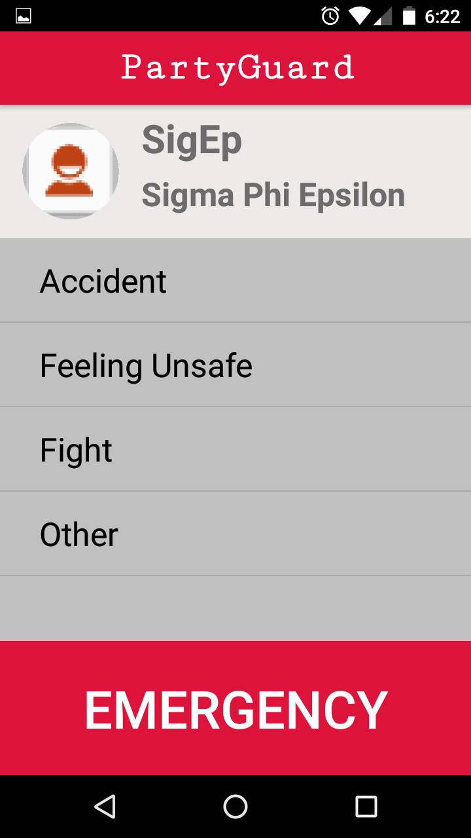

## Feature 8: Report Location Screen

User can choose his/ her location in this screen so that Fraternity team can locate the person.

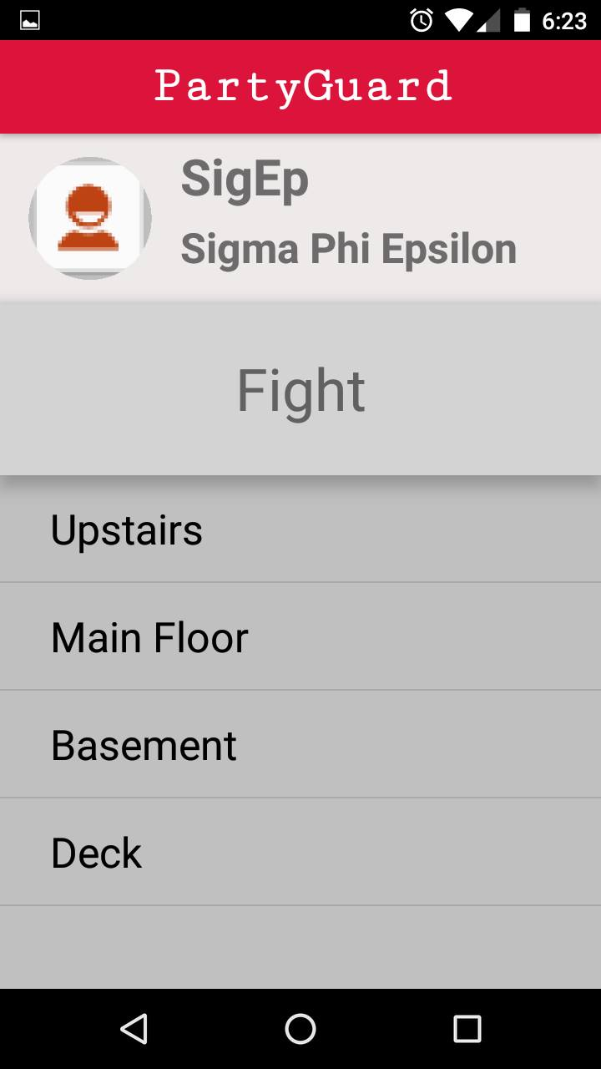

## Feature 9: Resolution Alert

Host user push a notification to the basic user (user who submitted the issue) to confirm if the issue is resolved. A pop-up message is shown of the basic user to confirm the resolution of the issue.

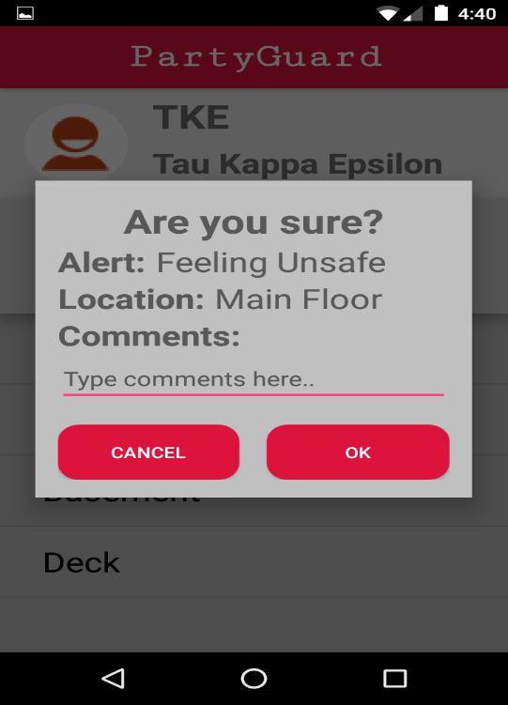

## Feature 10: Profile Dropdown Menu (or) Swipe Screen

This screen can be navigated by swiping from the left end of the screen (or) by clicking the dropdown menu () from the top left end of the screen.

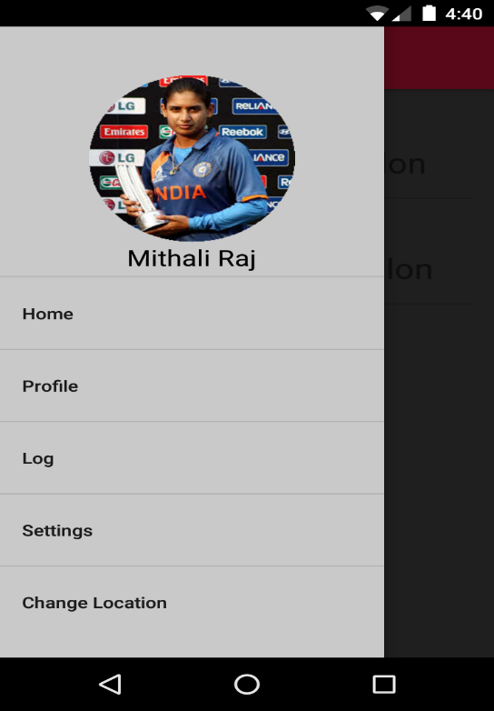

## Host/Guard- User interface design

## Feature 1: Host User Signup

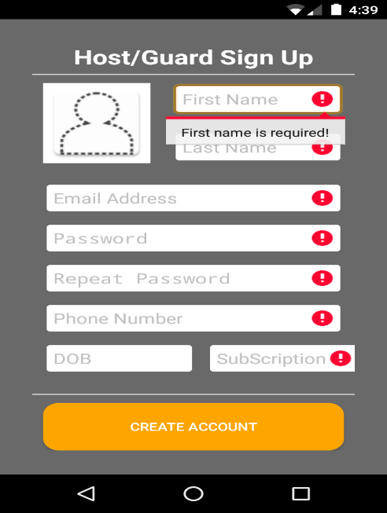

* The host/Guard user would be redirected to the login page when he/she opens the app and clicks on the Host/Guard User Login.
* User will be auto logged in after the first login.

## Feature 2: PG Team

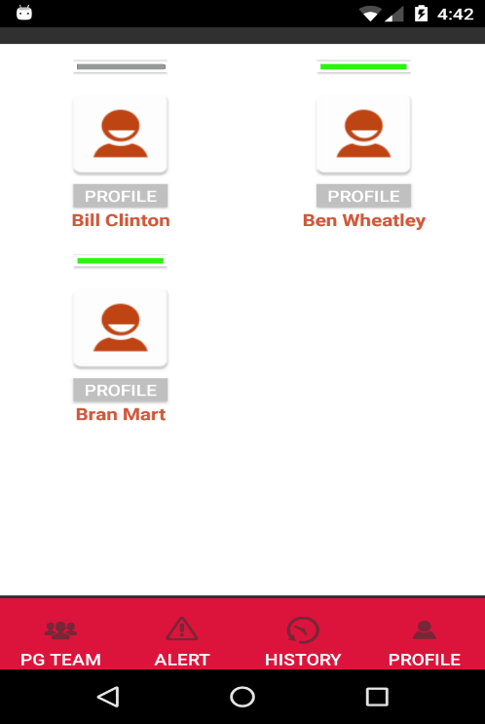

* This screen will be the host landing screen, when the host user logs into the account he/she will be able to see this screen.
* This screen shows the guard members who are in that fraternity.
* When the host user clicks on a member, his/her profile will be displayed.
* The “green” circle on the image indicates the members who will receive alerts.
* The members who are not in green in this screen will not receive any alerts.
* The user can select other tabs like alerts, history, and profile.

## Feature 3: Alert Screen

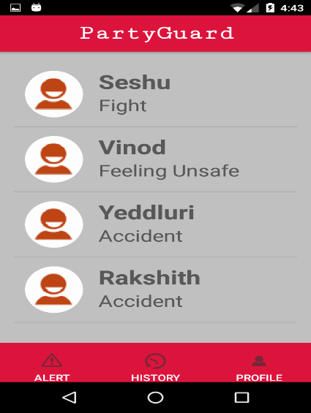

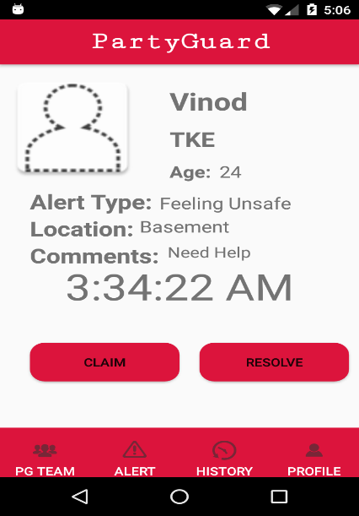

Host user should be redirected to the alerts page when he/she clicks on “Alerts” tab.

## Feature 4: History

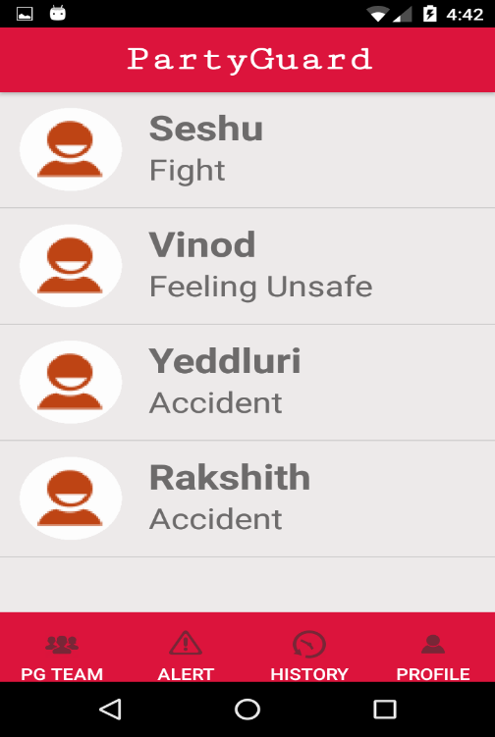

The host user can be able to see issues that were resolved from the past few days when he clicks on the “History” tab.

## Feature 5: Host/Guard Profile Screen:

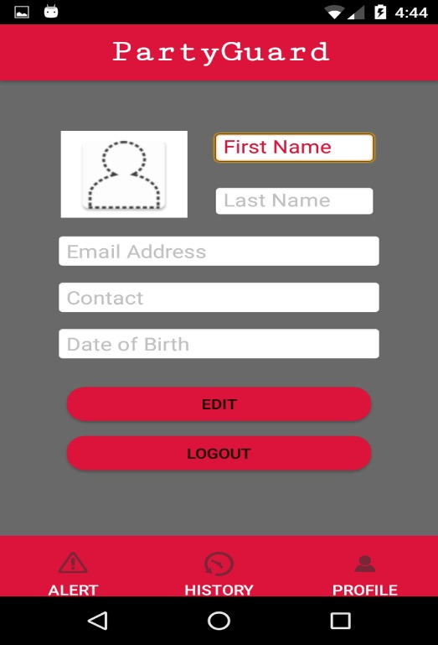

Host/Guard User should be re-directed to the profile page when he clicks on “Profile” tab in the Host/Guard landing screen.